# **ANALYZING USER PREFERENCES AND GENRE TRENDS IN ANIME**

**Amir Yimer**

**Andrew Mushinge**

**Aruna Pudhota**

**Manasa Cherukupally**

**Zubairuddin Mohammed**

**ADTA 5340 - Discovery and Learning with Big Data**

**Professor - Dr. Orhan**

**University of North Texas**

**July 26, 2023**

**Abstract**

In order to better comprehend the inner workings of the anime community, this study investigates the opinions and tastes of fans. The highest rated anime titles, most popular genres, association between popularity rank and average score, gender disparities in user ratings, and changes in user preferences depending on source material are all explored in this study, which aims to answer five research objectives. The results of a quantitative study based on a database of user reviews show some interesting trends. The findings highlighted popular anime titles, showed a negative association between popularity and average score, revealed preferences across genres, and revealed differences in user ratings based on gender. In addition, the study found that Light Novels and Manga are the most popular choices to adapt into anime. The suggestions made are meant to improve future research, ultimately boosting the development and creativity of the anime business by better recognizing and satisfying the tastes of its many fans.

**TABLE OF CONTENTS**

**ANALYZING USER PREFERENCES AND GENRE TRENDS IN ANIME** 1

**CHAPTER 1** 2

**INTRODUCTION** 2

**1.1** **Introduction** 2

**1.2** **Background to the Research Problem** 2

**1.3 Problem Statement** 3

**1.4 Research Questions** 4

**CHAPTER TWO** 6

**LITERATURE REVIEW.** 6

**2.1 Introduction** 6

**2.2 Unraveling the Complexities of Anime: Insights from Thomas Lamarre's ‘The Anime Ecology’** 6

**2.3 The Influence of Genre Preferences and User Trends among Fans: Examining Sexist Content and Attitudes in Anime** 7

***First Study: Analyzing Sexist Content in Popular Anime*** 7

***Second Study: The Relationship Between Anime Consumption, Genre Preferences, and Sexist Attitudes among Fans*** 7

**2.4 Exploring User Preferences and Generating Anime Recommendations: A Novel Hybrid Recommendation System for Anime** 8

**2.5 Anime Genre Preferences and Paranormal Beliefs** 9

**2.6 Anime Film Recommendation System Using Collaborative Filtering** 9

**CHAPTER THREE** 10

**METHODOLOGY** 10

**3.1 Introduction** 10

**3.2 Research Design** 11

**3.3 Dataset Variables** 11

**3.4 Data Preprocessing** 11

***Data Cleaning*** 11

***Handling Outliers*** 12

**3.5 Exploratory Data Analysis (EDA)** 12

**CHAPTER FOUR** 13

**DATA ANALYSIS & INTERPRETATION** 13

**4.1 Introduction** 13

**4.2 Descriptive Statistics** 13

**4.3 Research Question 1: What are the Highest-rated anime titles based on the user-ratings?** 15

**4.4 Research Question 2: What are the most popular genres among the anime enthusiasts?** 17

**4.5 Research Question 3: Is there a correlation between the popularity rank and the average score of the anime titles?** 18

**4.6 Research Question 4: How do User ratings differ based on Gender?** 21

**4.7 Research Question 5: Are there any notable trends in user preferences based on the source of the material?** 23

**CHAPTER FIVE** 25

**DISCUSSION, CONCLUSION & RECOMMENDATIONS** 25

**5.1 Discussion and Summary of Results** 25

***Objective 1*** 25

***Objective 2*** 25

***Objective 3*** 26

***Objective 4*** 27

***Objective 5*** 28

**5.2 Conclusion** 29

**5.4 Suggestion for Future Research** 30

**5.5 Recommendations** 30

**REFERENCES** 31

# **CHAPTER 1**

# **INTRODUCTION**

## **Introduction**

Anime, which originated in Japan, is a popular form of entertainment with stunning artwork, inventive ideas, and lively characters from all genres. This study analyzes the "My Animelist Dataset" to understand user preferences and anime genre trends. The study examines user ratings, genre popularity, and popularity rank-average score associations to understand anime fans' preferences. The study also examines gender differences in user evaluations and shows content creator preferences. The findings improve anime recommendation systems and help researchers understand anime fans' preferences.

## **Background to the Research Problem**

Anime has gained popularity worldwide. Fans often struggle to find shows that match their tastes in the large anime library. Recommendation systems utilize sophisticated algorithms to propose anime depending on user preferences. However, analyzing anime popularity and user preferences is crucial to improving these systems.

American culture has been shaped by anime's popularity. Over the past two decades, anime and manga have been incredibly popular in America, influencing American society, according to Trainer (2017). The manga style and anime revolution began with Osamu Tezuka's visionary works, especially Astro Boy. Over time, anime attracted US fans of all ages. Attendance at anime events, imported animation, and English-language translations of Hayao Miyazaki films has skyrocketed. The genre influenced American films and live-action anime adaptations. Anime's prominence in Japan and the US has influenced anime fans' favorite genres.

A study by Birlea (2019), delved into the release and reception of anime films and TV shows in the United Kingdom (UK), adopting a historical and critical perspective on the implementation of manganime culture. Compared to other European countries, the UK's integration of Japanese television products, including anime, had been slower and less consistent. Limited broadcasting of anime and stiff competition with British children's productions hindered its early growth on mainstream channels. However, the film, domestic video, and adult programming offered alternative entry routes. The study suggests that the future of anime in the UK depends on anime communities attracting distributor attention and demonstrating their commitment as engaged consumers, possibly correlating with the popularity rank and average score of anime titles.

The MyAnimelist dataset offers valuable insights into user ratings, genre trends, and anime characteristics, making it an invaluable resource for conducting insightful research. By analyzing this dataset, this research aims to uncover underlying patterns including the most highly-rated anime titles, prevalent genre preferences, and factors contributing to anime popularity. This will contribute to the development of more sophisticated recommendation systems, ultimately enhancing the discovery and enjoyment of anime for enthusiasts worldwide.

## **1.3 Problem Statement**

Anime enthusiasts exhibit diverse preferences and genre trends. By analyzing the "My Animelist Dataset," a comprehensive collection of user ratings and information about numerous anime series, this research examines the difficulty of identifying user preferences and genre trends in the anime community. In many parts of the world, there is a lack of understanding of the anime community's current user preferences and genre trends. Due to the wide range of tastes among anime fans, it is difficult to determine which anime titles are the most highly appreciated and popular.

Furthermore, it is critical to investigate whether there is any relationship between a series' popularity rank and the average user rating since this will provide insight into the alignment of popularity and perceived quality. Gender-based preferences in the anime community have sparked interest and debate, necessitating an investigation into how user ratings differed between male and female anime fans. Investigating trends in user preferences based on source material, such as manga adaptations or original storylines, is also critical to understanding the impact of source material on anime series reception.

Responding to the research questions reveals valuable insight into the anime community's pre-existing tastes, potentially contributing to advancements in recommendation systems. Personalized anime suggestions supplied by streaming platforms can be improved by acquiring a precise grasp of user preferences, ensuring that anime fans discover content that is connected with their tastes. Furthermore, the findings of the study can benefit content creators and anime studios in adapting their works to audience preferences, potentially leading to more lucrative and well-received anime series. Through a thorough examination of the "My Animelist Dataset," the study project will successfully fill a knowledge gap and give a greater understanding of user preferences, genre trends, and the factors driving anime aficionados' choices at the time. The findings of this study will provide significant information to the anime business and anime fans worldwide.

## **1.4 Research Questions**

The research paper seeks to address the following research questions:

1. What are the highest-rated anime titles based on user ratings?
2. What are the most popular genres among anime enthusiasts?
3. Is there a correlation between the popularity rank and the average score of anime titles?
4. How will user ratings differ based on Gender?
5. Was there any notable trends in user preferences based on the source material?

By addressing these research questions, the study aims to provide valuable insights into anime enthusiasts' preferences, genre trends, and popularity factors, contributing to the development of more effective recommendation systems in the anime domain.

# **CHAPTER TWO**

# **LITERATURE REVIEW.**

## **2.1 Introduction**

The review of the literature examines existing academic and research work on anime user preferences and genre trends. Understanding audience preferences and prevailing genre preferences is becoming increasingly important for content creators and streaming platforms as anime's popularity grows globally. This section explores current knowledge on the preferences of anime fans, popular genres, links between popularity and user ratings, gender-based preferences, and trends based on source material. The review intends to add valuable insights to the area and improve the researchers' understanding of the anime community by building on previous findings.

## **2.2 Unraveling the Complexities of Anime: Insights from Thomas Lamarre's ‘The Anime Ecology’**

Understanding the diverse anime industry requires exploring intricate connections between animation, television, and transmedia franchising. According to Gough (2018), Thomas Lamarre's work, "The Anime Ecology," offered valuable insights by decentering analyses from specific anime texts and focusing on media ecologies and related platforms. Research on media franchises beyond anime emphasized considering broader context, narrative texts, technology connections, and social engagement in anime consumption and viewer impact. Lamarre's analysis of Japanese media ecosystems and television networks highlighted distribution complexities, power relations, and anime genre trends. Lamarre's contributions provided valuable insights into the intricate dynamics within the anime world. "The Anime Ecology" promoted a holistic understanding of the anime ecosystem, offering lessons for analyzing user preferences and genre trends among enthusiasts worldwide.

## **2.3 The Influence of Genre Preferences and User Trends among Fans: Examining Sexist Content and Attitudes in Anime**

Sexism is a hot topic in the anime community, as the portrayal of gender norms and stereotypes in this popular medium continues to be scrutinized and analyzed. Reysen et al. (2017a) conducted two research to examine the prevalence of sexism in mainstream anime and the correlation between viewership, genre preference, and sexism in the anime fandom. These analyses provide insight into how gender is portrayed in anime and how it affects how viewers understand sexism in the medium.

### ***First Study: Analyzing Sexist Content in Popular Anime***

Reysen et al. (2017a) examined mainstream anime's sexism. Sexualization and aggression in male and female anime characters were examined. The results showed that popular anime underrepresented or sexualized female characters. There was no evidence that male protagonists were more hypermasculinized than male supporting characters. The research revealed sexist overtones in anime's portrayal of female characters and raised questions about how cultural norms affect the art.

### ***Second Study: The Relationship Between Anime Consumption, Genre Preferences, and Sexist Attitudes among Fans***

In their second piece of research, Reysen et al. (2017a) wanted to find out how anime fans' sexist attitudes were connected to their consumption of the medium and their preferences towards its many subgenres. The researchers gathered data from a sample of people who self-identified as being fans of anime and compared the degrees of ambivalent sexism they exhibited to those exhibited by other population samples. Overall, anime fans showed lower ambivalent sexism, indicating a more refined view of gender roles compared to the general population. The study did, however, discover a positive relationship between anime consumption and both hostile and friendly sexism among fans, implying that more exposure to anime may influence these sentiments.

The study explored the impact of anime genre preferences, including drama, action, and hentai, on fans' attitudes toward sexism. The findings indicate that drama and slice-of-life genres were associated with sexism, challenging traditional gender stereotypes depicted in anime. This emphasizes the intricate connection between anime consumption, genre preferences, and fans' perceptions of gender-related themes.

## **2.4 Exploring User Preferences and Generating Anime Recommendations: A Novel Hybrid Recommendation System for Anime**

Understanding user preferences and recommendations is crucial in the anime world to enhance viewers' personalized experiences and discover new captivating titles. In their groundbreaking study, Soni et al., (2023), addressed the scarcity of data on user preferences and viewing behavior in this relatively unknown entertainment medium by presenting a revolutionary hybrid recommendation system for anime enthusiasts. Their approach utilized deep autoencoders to predict ratings and generate embeddings, enabling the formation of clusters of anime titles with similarities. This unique hybrid filtering approach offered more sophisticated and accurate anime suggestions, providing users with an unparalleled viewing experience and higher satisfaction.

The model used by Soni et al., (2023), showcased its potential by conducting a comprehensive comparison with existing state-of-the-art techniques, outperforming other methods in terms of effectiveness. This research not only emphasized the significance of their novel model but also offered valuable insights into the future development of anime recommendation algorithms. By unlocking the power of deep autoencoders, this pioneering work opens up new possibilities for the anime industry, benefiting millions of users worldwide in their quest to find anime titles tailored to their unique tastes and preferences. The study lays the groundwork for a more immersive and gratifying anime-watching experience, shaping the future of personalized content discovery for anime enthusiasts everywhere.

## **2.5 Anime Genre Preferences and Paranormal Beliefs**

Past studies show that there is a correlation between anime fans' genre preferences and their beliefs in paranormal phenomena, suggesting a potential link between these features in the context of anime viewership. Reysen et al., (2017b), explored the link between anime fans' genre preferences and their acceptance of paranormal ideas. The survey found that anime fans were less likely to believe in the paranormal than college students. However, preferences for specific genres, like action and hentai, were linked to a stronger belief in the supernatural. In light of this, some worried about the impact that various styles of anime have on viewers' perceptions of the supernatural. A multidimensional measure of anime genre preferences was developed as a direct outcome of this study. This instrument was useful for revealing associations between anime fans' genre selections and their paranormal beliefs. This aids in gaining insight into the elements that shape the perspectives and tastes of anime fans.

## **2.6 Anime Film Recommendation System Using Collaborative Filtering**

Personalized content recommendations based on user choices and behavior have made recommendation systems important. To this goal, Girsang et al. (2020) created a collaborative filtering and Alternating Least Squares (ALS) algorithm-based anime movie recommendation system. The goal of this study was to improve upon a previous recommendation engine based on user viewing habits by analyzing a Kaggle dataset containing 73,516 people and 12,294 anime titles. The study demonstrated a robust method that helped millions of people find their ideal anime films, despite computing restrictions. By comparing user viewing histories with those of other users, the system was able to make precise recommendations that greatly improved the enjoyment of watching anime.

The primary goal of the study was to develop a reliable anime recommendation system that makes use of users' watching histories. The study showed that this approach could give tailored and relevant content suggestions, despite the small size of the dataset. Personalized recommendation systems have the potential to completely change the way that anime fans explore the large library of available titles, helping each individual find shows and movies that speak to their specific interests and preferences.

# **CHAPTER THREE**

# **METHODOLOGY**

## **3.1 Introduction**

The methods utilized to analyze the dataset and research user preferences and genre trends in the anime business are described in this section. To investigate numerous variables in the dataset, the study employed a systematic procedure that comprised data preprocessing and exploratory data analysis (EDA).

## **3.2 Research Design**

The study aimed to investigate five research questions related to anime titles and their audience. To achieve this, a quantitative research design was employed utilizing an existing dataset containing information on anime shows and user ratings.

## **3.3 Dataset Variables**

The dataset contained thirteen variables providing essential information about each anime title and user ratings. The dependent variable in this study was My Score, representing the user's rating for each anime on a scale of one to ten. The independent variables included Username, Anime ID, User ID, Gender, Title, Type, Source, Score, Score By, Rank, Popularity, and Genre. These independent variables encompassed diverse attributes such as user identifiers, anime characteristics, average scores, popularity rank, and genre classifications. Understanding the relationship between these variables was vital for investigating user preferences, genre trends, and factors influencing anime popularity in this research.

## **3.4 Data Preprocessing**

In the first stage of the analysis, the emphasis was placed on the preprocessing of the data in order to get the dataset ready for an accurate analysis. Several critical procedures were carried out during this stage in order to guarantee that the data would be consistent moving forward.

### ***Data Cleaning***

The dataset underwent a thorough investigation to locate and address any mistakes, inconsistencies, or missing values that may have been present. In order to guarantee that the statistics are accurate, incorrect data points were amended. Incomplete data records that were missing values were dealt with utilizing the most appropriate methods in order to lessen the effect that they had on the analysis.

### ***Handling Outliers***

Outliers, which are extreme numbers that depart greatly from the majority of the data, were looked into and appropriately addressed when the investigation was over.

The research ensured that the dataset was cleaned, converted, and made acceptable for subsequent exploratory data analysis and addressing the research questions by methodically doing data pretreatment. This allowed the research to successfully address the research questions. This comprehensive methodology laid the groundwork for extracting valuable insights into the preferences of anime industry users as well as trends in various genres of the medium.

## **3.5 Exploratory Data Analysis (EDA)**

Several techniques were used during exploratory data analysis (EDA) to learn more about the anime dataset. Measures of central tendency and dispersion were among the summary statistics computed to offer context for the numbers. Bar charts and other visualizations were used to learn about the popularity of various types of anime and to determine which topics were the most widely discussed among viewers. During the summary statistics phase, a pie chart was used to illustrate the percentage of male and female users in the anime dataset. The gender breakdown of anime fans in the dataset may be grasped quickly thanks to the pie chart's clear and concise representation of the distribution.

The average score of anime titles was plotted against their popularity using scatter plots to see if highly rated series were more popular with viewers. To further explore user preferences as they relate to the provenance of the anime content, we further sorted the dataset by its source material and computed average user ratings and popularity ranks. Together, these techniques allowed for a thorough investigation of the dataset, paving the way for future studies in the anime field.

# **CHAPTER FOUR**

# **DATA ANALYSIS & INTERPRETATION**

## **4.1 Introduction**

The analysis and interpretation of data are fundamental to the success of any study or undertaking. In this paper, the researcher focuses on "anime," a large dataset filled with information about anime shows. In addition, the researcher uses statistical techniques to identify patterns, trends, and causal relationships. In order to shed light on topics such as audience tastes, program popularity, and anime rating criteria, the study employs data visualization and correlation analysis. The results of this data-driven analysis will help the researcher better comprehend the anime industry and make educated business and research decisions.

## **4.2 Descriptive Statistics**

After data-preprocessing, the researcher calculated the summary statistics of the dataset to explore the characteristics of different variables in the dataset. Table 1 shows a summary of the descriptive data for the "my_score," "score," "scored_by," "rank," and "popularity" variables. There are 35,305,700 records for each variable in the cleaned dataset. The mean numbers for "my_score" and "score" are 4.59 and 7.53, respectively. This shows that the average scores given by users are lower than the official scores. The standard deviation for "my_score" is 3.91, while it is only 0.73 for "score." This shows that user-assigned scores vary more. The "scored_by" variable has a mean of about 109,650 and a large standard deviation of 148,300. This suggests that the number of users who rated each item was very different.

Also, the "rank" variable has a mean value of 2,045.87, which means that, on average, anime shows are placed in the middle of the list. But the fact that the standard deviation is so high (1,972.33) shows that users' ranks vary a lot. The "popularity" variable has a mean value of 1,335.95, which shows that the anime shows are fairly popular. The standard deviation of 1,563.16 shows that, like the "rank" variable, the "popularity" variable also has a lot of variation.

**Table 1: Summary Statistics**

|  |  |  |  |  |  |
| --- | --- | --- | --- | --- | --- |
|  | my_score | score | scored_by | rank | popularity |
| Count | 3.53E+07 | 3.53E+07 | 3.53E+07 | 3.46E+07 | 3.53E+07 |
| Mean | 4.59 | 7.53 | 1.10E+05 | 2.05E+03 | 1.34E+03 |
| Std | 3.91 | 0.73 | 1.48E+05 | 1.97E+03 | 1.56E+03 |
| Min | 0 | 1.9 | 2.00E+02 | 1.00E+00 | 1.00E+00 |
| 25% | 0 | 7.11 | 1.74E+04 | 5.00E+02 | 2.51E+02 |
| 50% | 6 | 7.56 | 5.39E+04 | 1.41E+03 | 7.69E+02 |
| 75% | 8 | 8.03 | 1.40E+05 | 3.04E+03 | 1.82E+03 |
| Max | 10 | 9.25 | 1.01E+06 | 9.53E+03 | 1.03E+04 |

Figure 1 displays the distribution of Gender among the participants. The pie-chart illustrates that the majority of respondents identified as male, accounting for 71.8% of the sample. Female participants constituted 27.5% of the group, while individuals who identified as non-binary represented a smaller proportion, comprising only 0.7% of the total sample.

**Figure 1: Distribution by Gender**

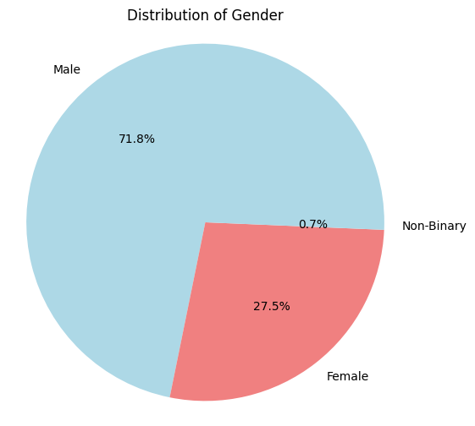

## **4.3 Research Question 1: What are the Highest-rated anime titles based on the user-ratings?**

Figure 3 illustrates the top-rated anime titles based on user-ratings. The table presents a list of anime shows that have received a perfect score of 10, indicating the highest possible user-rating. The titles include "Bishoujo Senshi Sailor Moon: Sailor Stars," "Fruits Basket," "Clannad: After Story," "Tantei Gakuen Q," "Pokemon Diamond & Pearl: Arceus Choukoku no Jikuu e," "Angel Beats!," "Mahou Shoujo Lyrical Nanoha," "Pokemon Diamond & Pearl: Giratina to Sora no Hanataba Sheimi," "Hametsu no Mars," and "Pokemon Diamond & Pearl: Dialga vs. Palkia vs. Darkrai." These anime shows have garnered exceptional user appreciation, with each receiving a perfect score from the respondents in the dataset.

Table 2:Highest-rated anime titles based on the user-ratings

|  |  |
| --- | --- |
| title | my_score |
| Bishoujo Senshi Sailor Moon: Sailor Stars | 10 |
| Fruits Basket | 10 |
| Clannad: After Story | 10 |
| Tantei Gakuen Q | 10 |
| Pokemon Diamond & Pearl: Arceus Choukoku no Jikuu e | 10 |
| Angel Beats! | 10 |
| Mahou Shoujo Lyrical Nanoha | 10 |
| Pokemon Diamond & Pearl: Giratina to Sora no Hanataba Sheimi | 10 |
| Hametsu no Mars | 10 |
| Pokemon Diamond & Pearl: Dialga vs. Palkia vs. Darkrai | 10 |

## **4.4 Research Question 2: What are the most popular genres among the anime enthusiasts?**

The top 10 most popular genres among fans of anime are presented in Figure 4. The chart presents an overview of the musical categories that have received the highest levels of attention and interaction in relation to the dataset. In descending order, the most popular types of stories are comedies, slices of everyday life, school stories, magical stories, fantasy stories, and action stories. These subgenres have a strong hold on the anime community, and as a result, they have attracted a sizeable number of fans who are enthusiastic about the themes and storytelling features that are distinctive to each subgenre. The findings bring to light the varied tastes of anime viewers and throw light on the kind of anime that have most resonated with the audience represented in the dataset.

Figure 4: Top 10 popular Genres

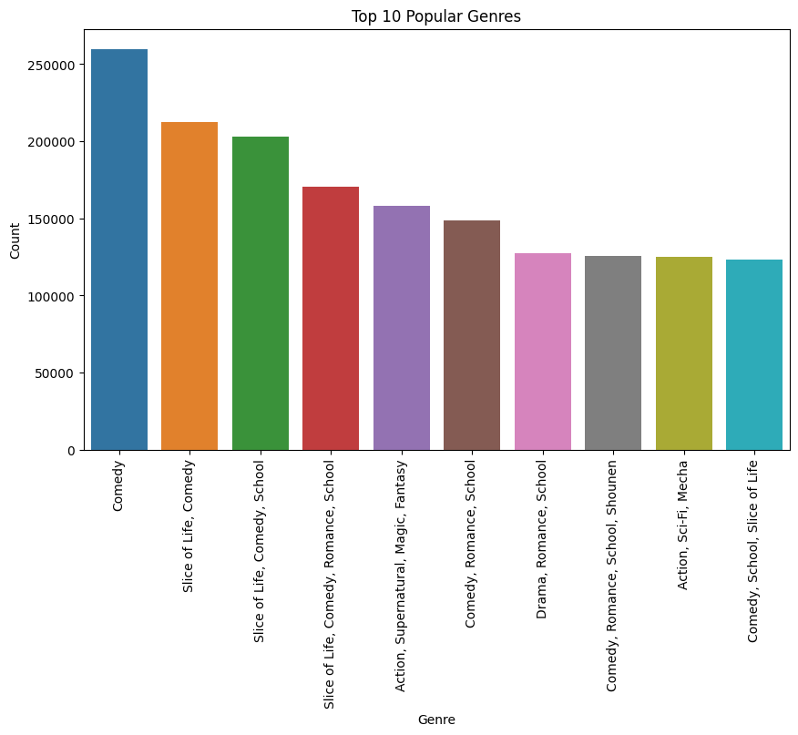

## **4.5 Research Question 3: Is there a correlation between the popularity rank and the average score of the anime titles?**

In order to find an answer to Research Question 3, a quantitative study was carried out to investigate the correlation between the popularity rank and the overall score of the anime titles included in the dataset. The popularity rank is a representation of each anime title's relative popularity, while the average score is a representation of the mean user rating that has been provided to the anime.

According to the findings, there is a negative correlation that ranges from fairly strong to extremely strong between the popularity rank and the average score. This correlation is depicted graphically in Figure 5 as a scatterplot, which reveals a downward tendency in which anime titles with higher popularity ranks tend to have lower average scores. On the other hand, titles whose popularity ranks are lower tend to have higher average scores.

The fact that the correlation between these variables is -0.57 (as displayed in the scatter matrix in figure 6), demonstrates that there is a negative association between them. The existence of a negative connection between the two variables shows that when the popularity rank goes up, the average score goes down.

Figure 5: A Scatterplot Showing the relationship between Average Score and User ratings

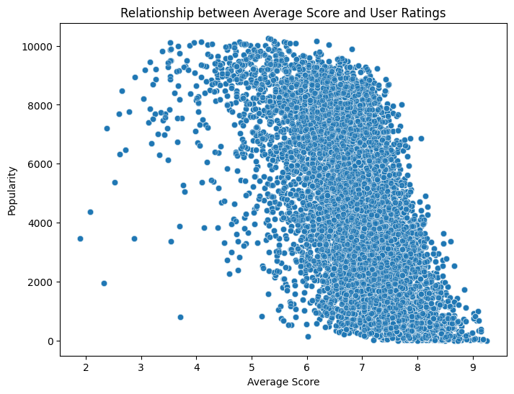

Figure 6: Correlation Matrix

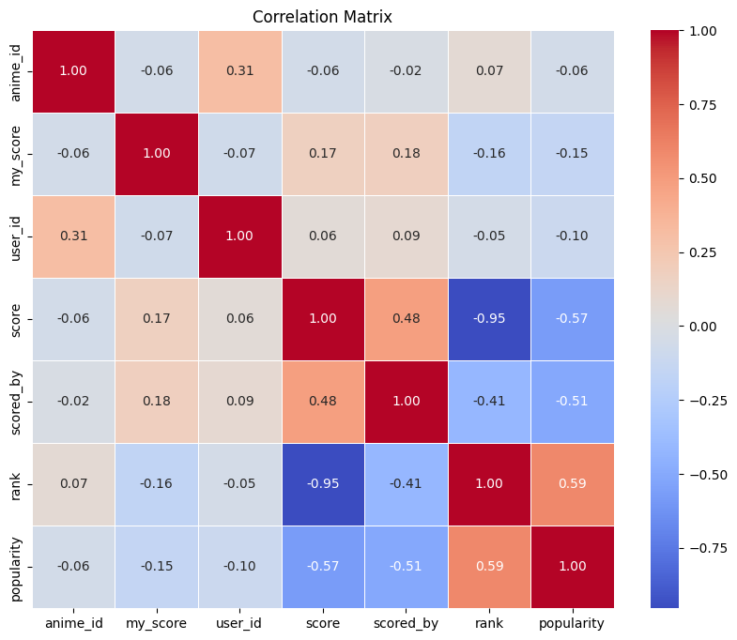

## **4.6 Research Question 4: How do User ratings differ based on Gender?**

To answer this research question, the researcher conducted a comparative analysis to see if there were any differences in the ratings users gave based on their Gender. Gender was used to divide the dataset into male, female, and non-binary sections. Participating anime fans were divided into groups based on their self-identified Gender during the rating procedure.

According to the results, there is a clear difference in the evaluations given by users of different sexes. Across all three sex groups, male contributors received the highest average user rating. This data may indicate that men anime viewers, on average, are more generous in their evaluations of the medium than their female counterparts. Female participants showed the second-highest average user rating, after male participants, demonstrating a positive appreciation for anime titles. The male participants mirrored this finding. Last but not least, the non-binary category had a lower average user rating, suggesting that non-binary respondents often gave lower ratings. This may suggest that non-binary respondents had a lower level of satisfaction with this group.

Figure 7: Average Rating by Gender

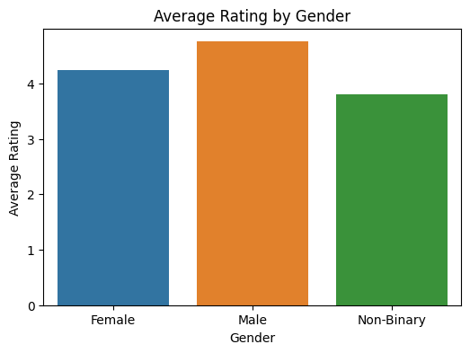

## **4.7 Research Question 5: Are there any notable trends in user preferences based on the source of the material?**

To investigate Research Question 5, an analysis was conducted to identify any discernible trends in user preferences based on the source material of anime titles. The dataset was categorized according to the source material, and the average rating scores (user preferences) were calculated for each category.

The results reveal a distinct ranking of source materials based on the average rating scores, indicating varying levels of user preference. The source materials ranked from highest to lowest average rating scores are as shown in figure 8 below.

Figure 8: User Preferences based on Source Material

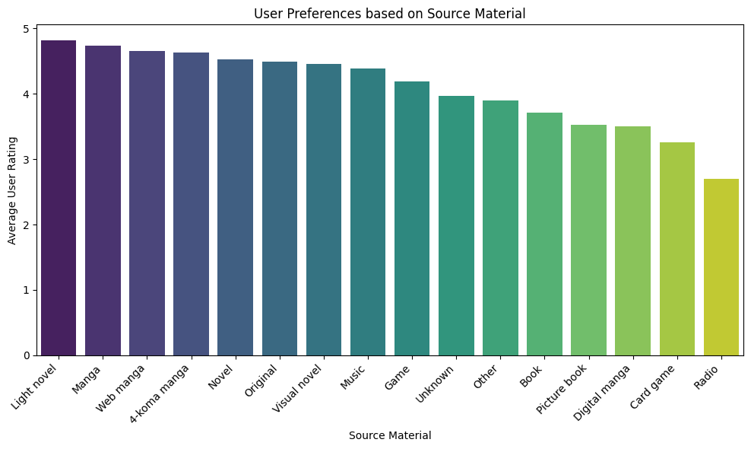

# **CHAPTER FIVE**

# **DISCUSSION, CONCLUSION & RECOMMENDATIONS**

## **5.1 Discussion and Summary of Results**

### ***Objective 1***

The first objective of the study was to find out the highest-rated anime titles based on the user ratings. There appears to be a tendency indicating that certain anime titles consistently earn high user ratings, which is suggestive of their continuing popularity and resonance with the anime community, even if different research may come to different results. This pattern may be explained by the lasting popularity of these works. Researchers often evaluate the impact of story, character growth, animation quality, and thematic elements when examining anime viewer ratings and preferences.

The current study's emphasis on the most highly rated anime titles is consistent with past studies assessing user preferences and appreciation in the anime sector. The results of this study lend credence to this conclusion. The continued popularity and international acclaim of anime is evidenced by the pervasiveness of critically acclaimed shows, even if the titles of particular series may alter from one study to the next. The results add depth to our knowledge of both viewer preferences and the factors that lead to high user ratings in the anime entertainment industry.’

### ***Objective 2***

The second objective was to find out the most popular genres among the anime enthusiasts. Research Question 2 reveals the anime community's favorite genres. Comedy, slice of life, school, magic, fantasy, drama, and action are the most popular genres, in descending order of user involvement.

These genres reflect anime fans' varied tastes. Some genres (comedy, slice of life, school) emphasize on lighthearted humor and everyday situations, while others (magic, fantasy, action) take viewers to fantastic realms and dramatic battles. Drama adds depth and variety to anime tastes. These findings help content creators, anime producers, and researchers choose and make audience-friendly anime. It's important to remember that viewers may want a mix of genres.

The top anime genres show the variety and appeal of anime narrative. The wide variety of themes and styles in anime shows its lasting appeal as a form of entertainment and artistic expression.

### ***Objective 3***

Research Question 3 shows a negative association between popularity rank and average anime score. This study found a negative association between anime popularity and average user scores. Reysen et al., (2017b) found similar results, implying that previous studies support the current research findings. Conversely, titles with lower popularity levels have higher average scores, suggesting that lesser-known anime may garner higher user evaluations. This discovery may provide light on anime fan preferences and popularity.

This negative association may be due to the "bandwagon effect" or "popularity bias." People follow trends or popular beliefs due to the bandwagon effect. Popular anime titles may draw in viewers who don't like the genre or storyline. Due to more different audience perspectives, certain anime titles may have lower average scores.

However, niche anime titles may draw a loyal following interested in their subjects, genres, or narrative. Due to their tremendous appeal to their target audience, certain anime titles may get higher average scores.

This study found a negative link between popularity rank and average score. Popular movies and products may earn more polarized ratings than niche or less well-known ones, according to movie ratings and consumer preference studies. In the context of anime, specific research focusing on user ratings and popularity may not be directly comparable to this study due to variations in datasets, sample sizes, and methodologies. However, the underlying principle of the bandwagon effect and its potential impact on user ratings and popularity is a recurring theme in various media-related research.

### ***Objective 4***

The fourth objective was to investigate how user ratings differ based on Gender. User ratings by Gender differ significantly. Male contributors had the highest average user rating among all genders, demonstrating that male anime watchers score anime titles better on average. This suggests that male respondents may rate anime content more generously than female and non-binary respondents.

Female anime fans had the second-highest average rating. Female anime fans also like anime content; however they score significantly lower than male participants. Male participants also had higher average user ratings, reinforcing the idea that men like anime more. However, non-binary respondents gave anime titles lower average user ratings. This suggests non-binary individuals were less satisfied with their anime ratings.

This study supports earlier studies on gender and media evaluations and preferences. Movie ratings, book reviews, and consumer preferences have shown gender-based judgments. Several studies show that men rate movies and media content higher than women. Male book reviewers may also be more generous than female readers. Male anime viewers had higher average user ratings than female and non-binary viewers, confirming these trends. Gender-based user ratings highlight the necessity of considering varied audience opinions in anime content creation, marketing, and broadcasting.

### ***Objective 5***

Research Question 5 examined user preferences based on anime source material. The dataset was categorized by source material, and average rating scores (user preferences) were determined for each category. The average rating scores rank source items differently, showing user preference. Light Novel and Manga adaptations had the highest average rating scores, demonstrating a significant user preference for these adaptations. Anime fans love light novels for their unique stories. Manga, with its vast source material and loyal fanbase, is also a popular anime adaptation. Web Manga and 4-Koma Manga were well-received by anime fans. Novel, Original, Visual Novel and Music rankings show varying user admiration for these sources.

Anime titles based on Card Games and Radio have lower average rating scores, indicating lesser user preference. Unknown and Other categories demonstrate anime's many source materials.

While this dataset has not been studied before, user choices based on source material match anime community insights. Due to their well-developed narratives, characters, and passionate fanbases, light novels and manga have always been popular anime adaptations.

The increased popularity of web-based content and comedy and slice-of-life anime genres is reflected in Web Manga and 4-Koma Manga. Card Games and Radio anime may have particular adaptation issues or appeal to niche audiences, as shown by their lower average rating scores.

## **5.2 Conclusion**

This research looked into the opinions and preferences of anime viewers in order to shed light on the nature of the anime fandom as a whole. The answers to five quantitative research questions shed light on how viewers engage with anime media. The first research question looked at the most popular anime of all time. A number of outstanding anime series received a perfect score of 10, proving their enduring popularity and widespread resonance among anime fans. These highly regarded works of animation should not be missed. The second research question looked at popular anime. Audiences clearly choose comedic, slice-of-life, fantastical, and action-packed content. The varied opinions reflect the depth and breadth of anime's storytelling and philosophical inquiry.

The third research question looked into how well-liked an anime was on average. The average user rating for popular anime titles is lower than for less well-known shows, indicating a negative correlation. This exemplifies the complexity of anime's fan base as well as the bandwagon effect. User evaluations differed by Gender, per Question 4 of the study. Overall, respondents who identified as male or female provided higher ratings than those who did not. Understanding gender differences in their consumers is helpful for content creators and streaming services. The fifth research question looked into people's favorite places to watch anime online. The highest aggregate scores were given to works of manga and light novel. This highlights the importance of interesting source materials in successful anime adaptations and the wide range of artistic options available to animators.

The findings of this study shed light on the dynamics and tastes of anime viewers. It exemplifies the richness and variety of the anime genre and the interests of its viewers. Anime content makers, producers, and streaming services can use the findings of this study to make more impactful and enjoyable programming.

## **5.4 Suggestion for Future Research**

Given the potential influence of cultural context and individual preferences on user ratings, the dataset may not be representative of the anime community at large. These are all questions that could be explored in future research to shed light on who watches and enjoys anime.

## **5.5 Recommendations**

In future studies, it is suggested that both quantitative and qualitative methods of analysis should be used together. Important areas of research include finding out what genres people like, how sources affect evaluations, and how Gender and portrayal affect user evaluations. Streaming platforms and production companies could use study to improve their content marketing strategies. This could also help professionals in the field form partnerships. We can learn more about anime fandom if we don't just look at ratings, but also look at the cultural background and how users participate.

# **REFERENCES**

Birlea, O. (2019). From Kawaii to Sophisticated Beauty Ideals: A Case Study of Shiseid? Beauty Print Advertisements in Europe. *Mutual Images Journal*, (6), 53-69.

Girsang, A. S., Al Faruq, B., Herlianto, H. R., & Simbolon, S. (2020, June). Collaborative recommendation system in users of anime films. In *Journal of Physics: Conference Series* (Vol. 1566, No. 1, p. 012057). IOP Publishing. <https://iopscience.iop.org/article/10.1088/1742-6596/1566/1/012057/pdf>

Gough, S. (2018). Review of Lamarre, Thomas, The Anime Ecology: A Genealogy of Television, Animation, and Game Media. *electronic journal of contemporary japanese studies*.<https://japanesestudies.org.uk/ejcjs/vol18/iss3/gough.html>

Reysen, S., Katzarska-Miller, I., Plante, C. N., Roberts, S. E., & Gerbasi, K. C. (2017a). Examination of anime content and associations between anime consumption, genre preferences, and ambivalent sexism. *The Phoenix Papers*, *3*(1), 285-303. <https://www.academia.edu/34409907/Examination_of_Anime_Content_and_Associations_between_Anime_Consumption_Genre_Preferences_and_Ambivalent_Sexism>

Reysen, S., Plante, C. N., Roberts, S. E., & Gerbasi, K. C. (2017b). Anime genre preferences and paranormal beliefs. *The Phoenix Papers*, *3*(1), 327-343. <https://www.academia.edu/34409933/Anime_Genre_Preferences_and_Paranormal_Beliefs>

Soni, B., Thakuria, D., Nath, N., Das, N., & Boro, B. (2023). RikoNet: A Novel Anime Recommendation Engine. *Multimedia Tools and Applications*, 1-20. <https://arxiv.org/pdf/2106.12970.pdf>

Trainer, M. (2017, June 28). Anime’s supersized U.S. audience <https://share.america.gov/animes-supersized-u-s-audience/>